Assist COVID 19 Updates
- We have re-written the suspected COVID19 infection templates to reflect current (ever changing) guidance and to reflect a clinician’s workflow better.
You access them the same way
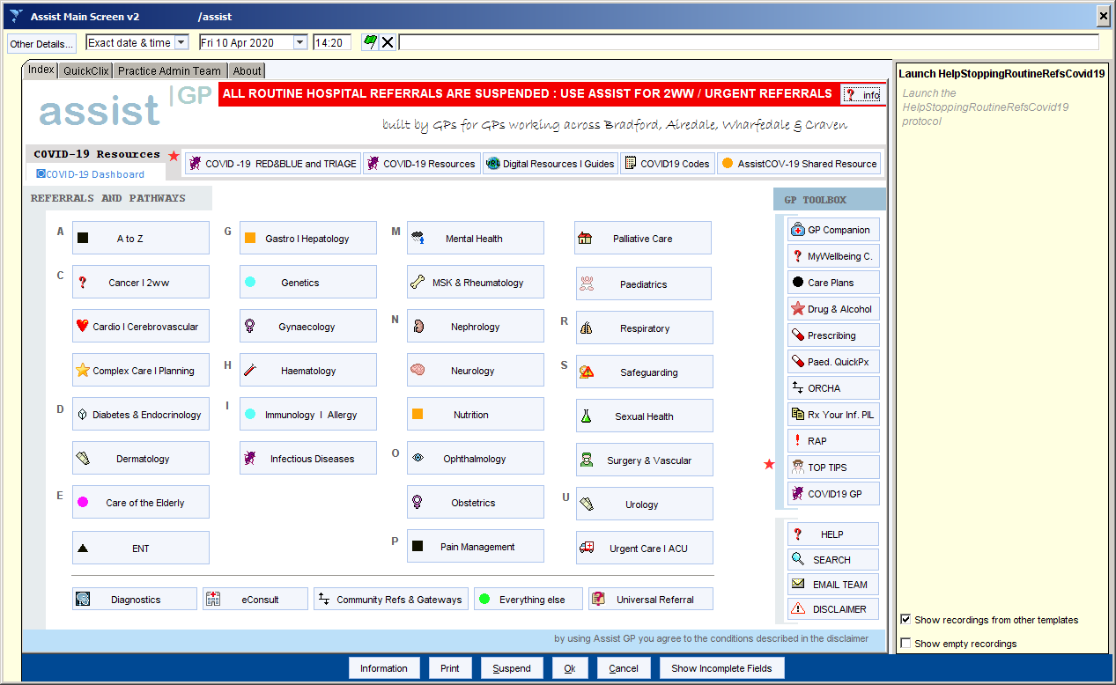
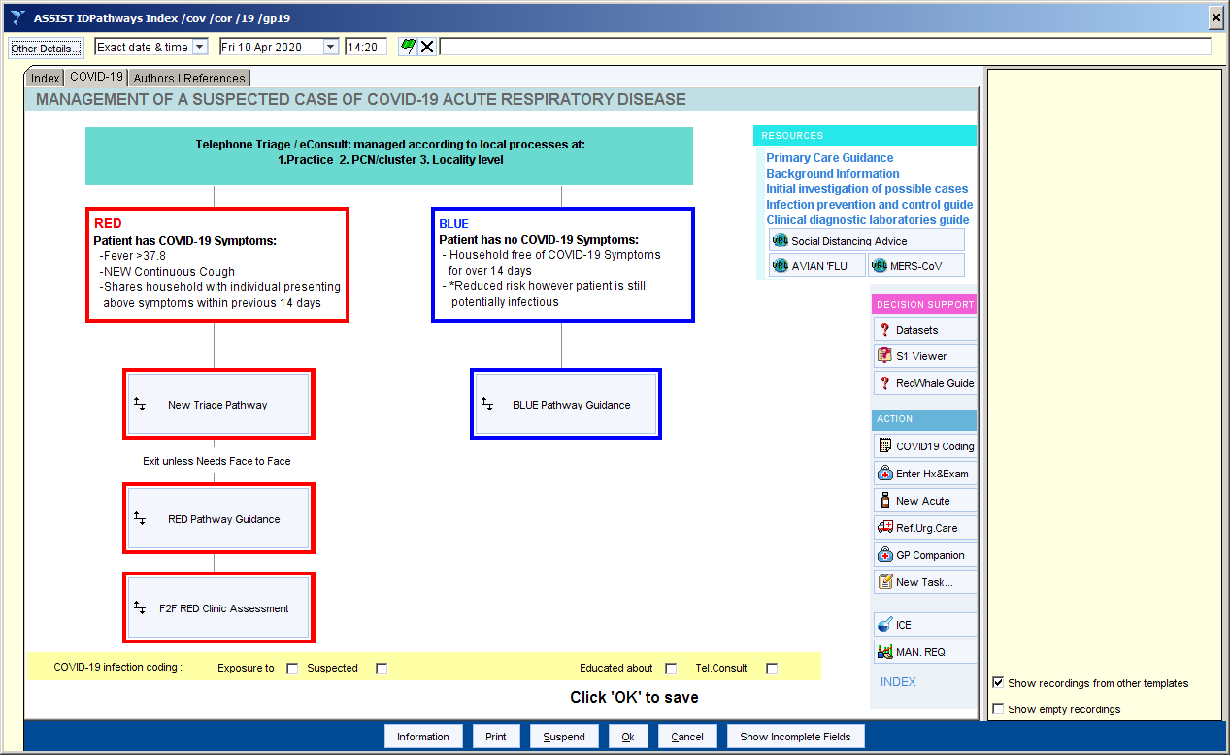

New history taking, supported history and red flags data entry , examination and resource support screen
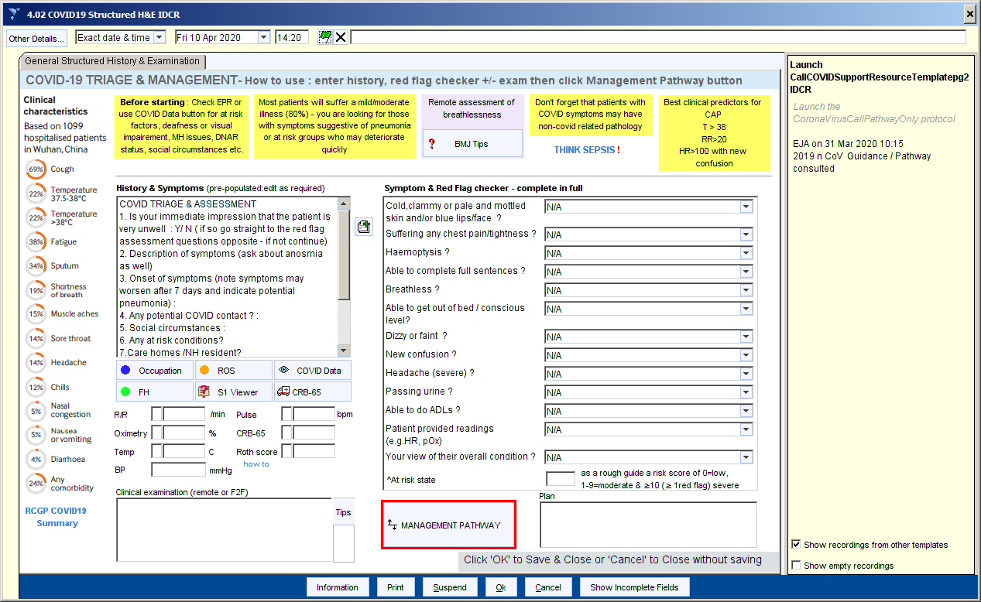
Management screen with a lots of additional information using the ‘here’s how’ and other box buttons (content being added to this as the clinical teams write it – they are working really hard to get this content to you asap) . Please ensure you tick a relevant COVID code in the yellow box (this will be mandated in the next release this weekend so we can flag ‘suspected COVID’)
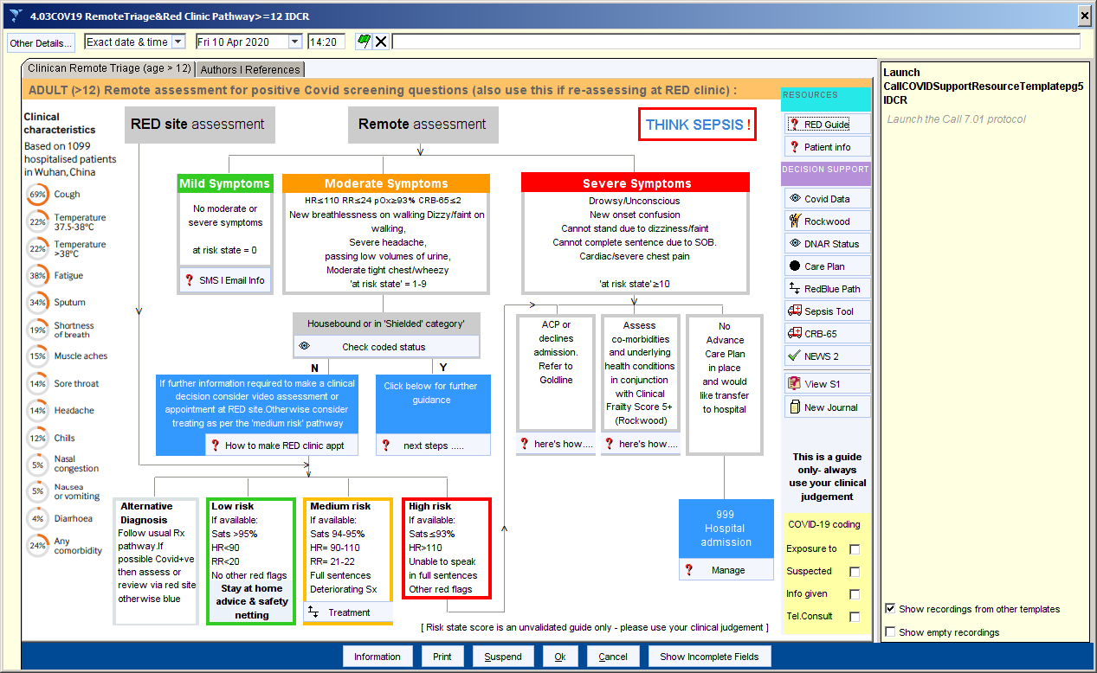

And treatment screen . Based on NICE but also local specialist feedback on the clinical pathways groups.
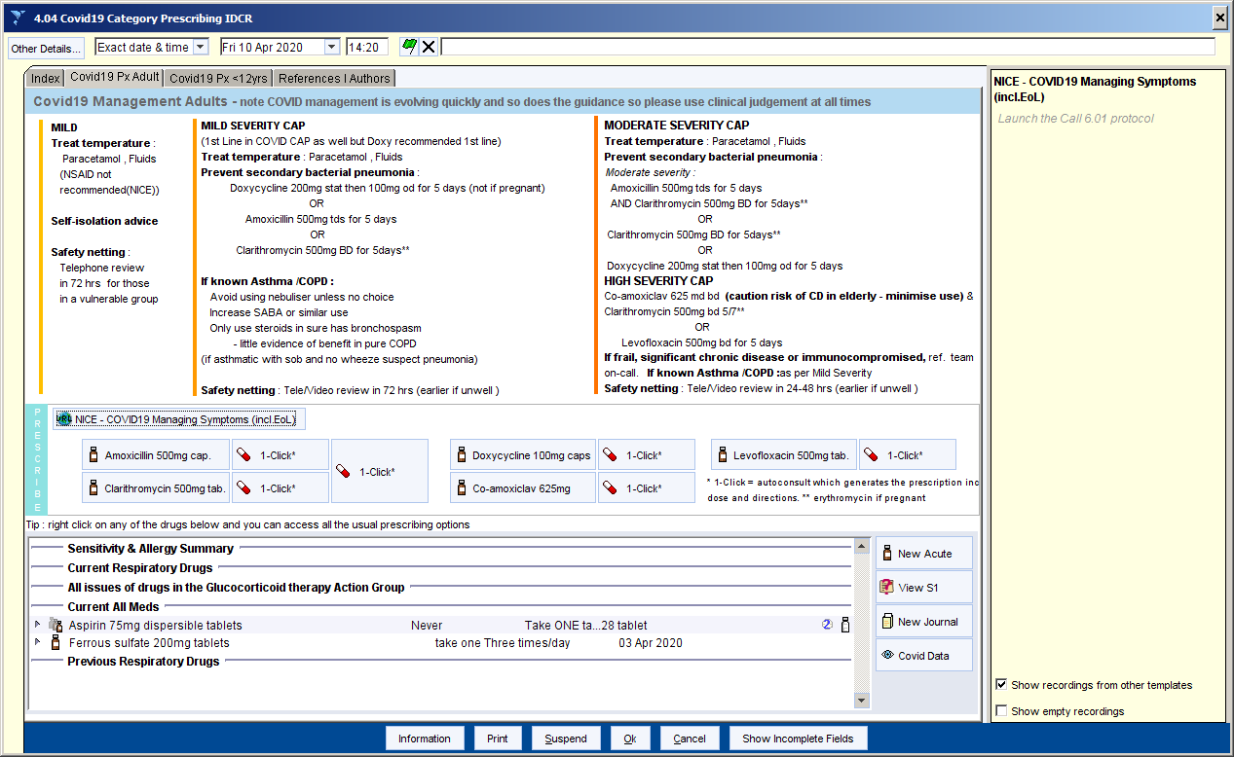

2. AssistCOV-19

This is a version of Assist built to support users in non-GP units, especially the Telehealth staff including super-rota clinicians. It is available as shown below. You will also note that the daily COVID dashboard has been added as well to both Assist GP and AssistCOV19 which gives you all the Covid stats across the district

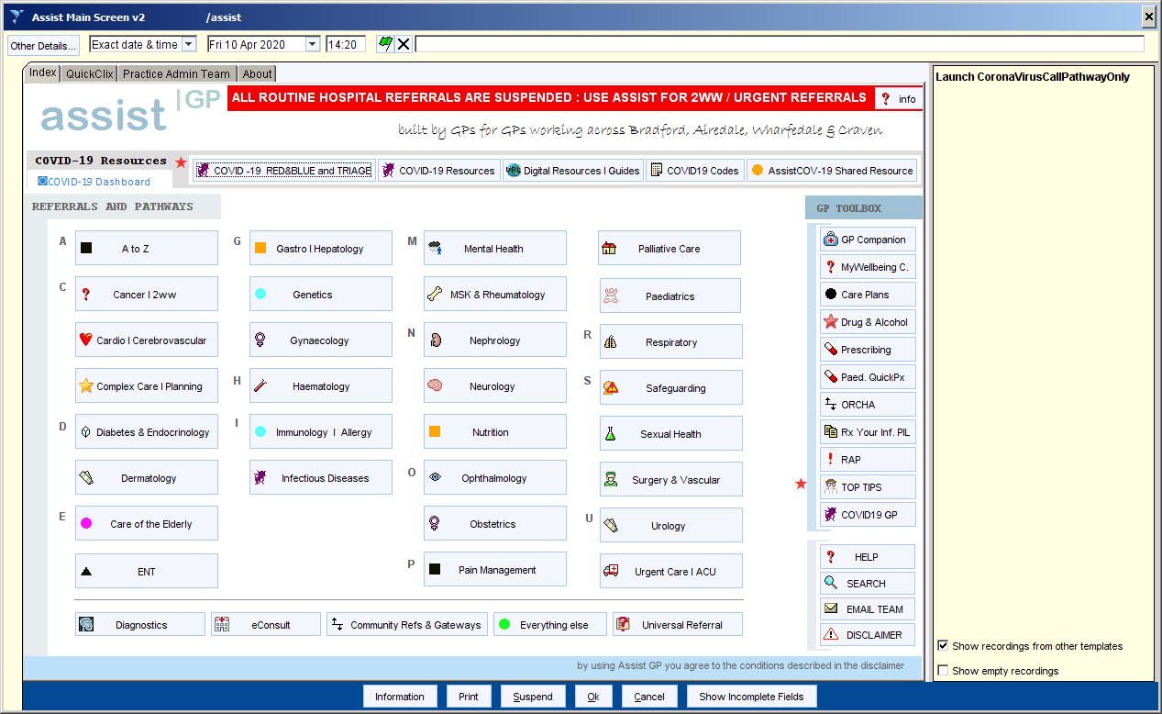

AssistCOV19 is where we will put all the specific COVID19 resources, especially around management of Care Home, Housebound, Frail and at Risk patients. There is also resource around verification and certification of death during COVID (this is a lot different so please read it) as well as EoL management ,management of non-covid issues in a covid setting such as falls, fractured NOF & head injury . The Care Homes working group is constantly adding and updating this content & working extremely hard.

Please familiarise yourself with this content . When we manage to take a breather many of these currently document based pathways will be transcribed into Assist pathways but for now please bear with us. We felt it better to get the content to you ASAP and then build the templates afterwards.
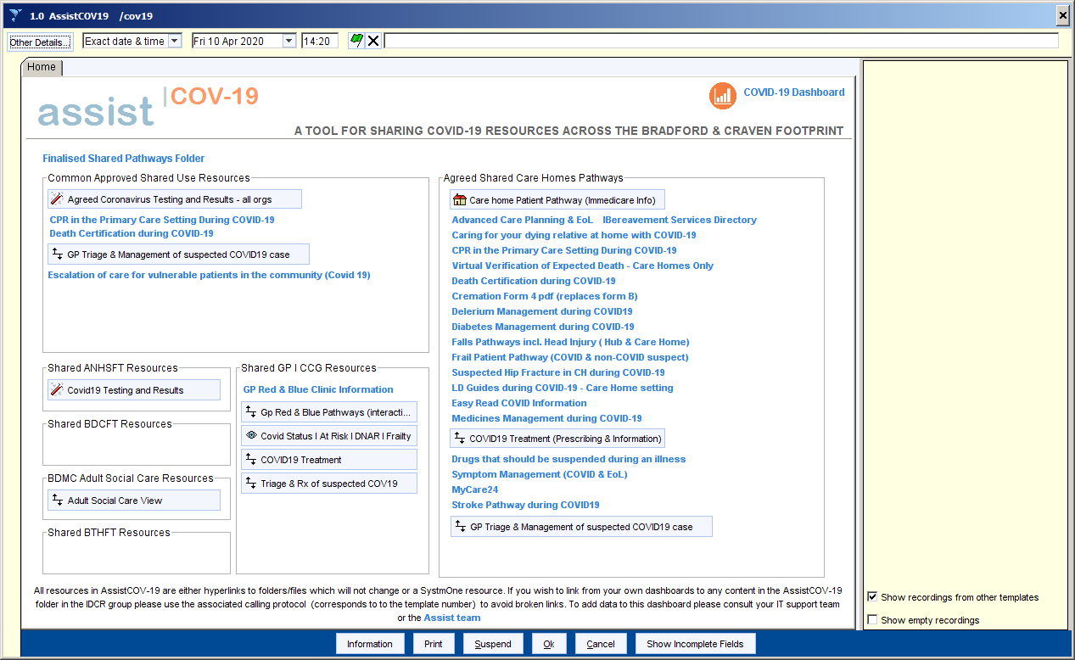

COVID19 – status markers
As per a previous communication you will be aware that there are now RAG based status markers in the patient demographic box denoting ‘positive test’, ‘tested but no result’ and ‘negative test’.

We have added a ‘suspected’ or ‘positive’ pop-up. This will trigger for any patient whose record contains a Covid19 ‘suspected’ or ‘positive based on clinical criteria code’ (with no subsequent proven positive or negative) within the last 3weeks and also any patient with a proven Covid positive code with no subsequent negative code in the last 3 weeks.. This relies on clinicians remembering to code this in the record for any patient they see fulfilling the symptomatic criteria and I recommend you do this via the COVID19 triage template or the coding template (available on the front screen of Assist GP banner). I have also updated the template codes to include the positive and negative on clinical criteria codes.

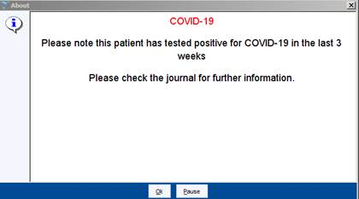
Suspected:

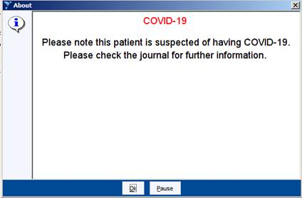
For practices that may already be flagging please ensure your coding is consistent with Assist GP and the patch wide coding convention detailed on the coding template before you consider switching the Assist GP status flag off. I will you wish to switch the flag off for your organisation (not recommended) then untick ‘Covid 19 positive’ and the ‘Covid-19 suspected’ protocols

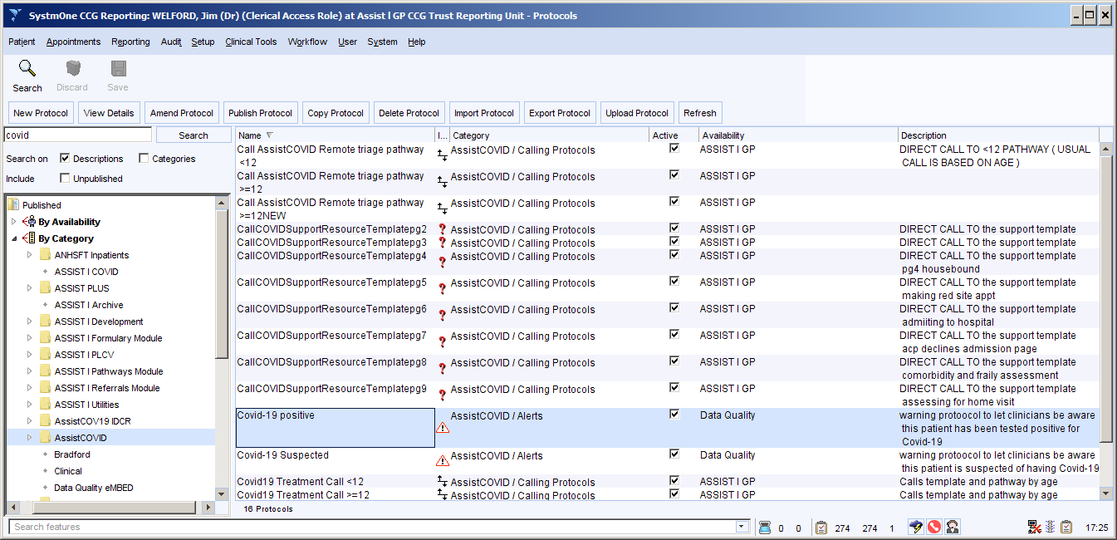

Stay safe and healthy

Best wishes to all.

Jim
Dr Jim Welford

